Cable and wires

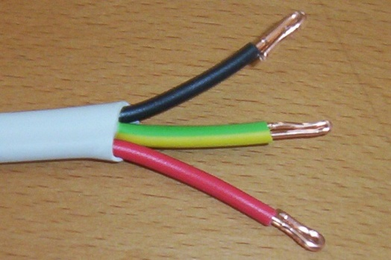
Three wires of the same radius are wrapped with a plastic outer layer to form a blue cable.

The cross-section contains four circles shown below.

Find the ratio of the total area of the three wires (in red) to the area of empty space (in white) inside the large cable (in blue).

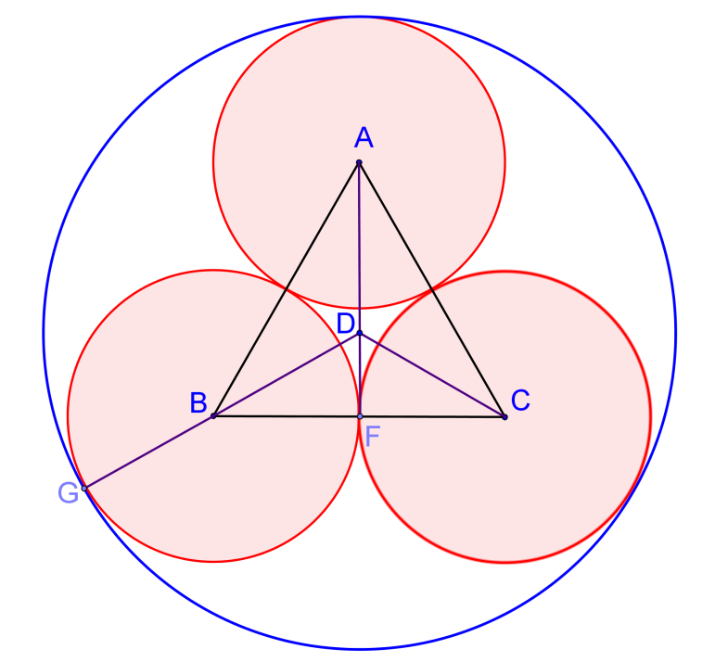
Solution

As in the diagram in the right, let $A,B,C$ be the centres of the small red circles.
Then $∆ABC$ is an equilateral.
Draw $AF$ perpendicular to $BC$.
Let $D$ be the centre of the outer blue circle.
Draw $DB$ and produce to meet the outer circle at $G$.

For simplicity, let the radii of the three smaller circles be 1.

$∆BDF$ is a $30°-60°-90°$ triangle.
Since $BF=1$, $BD=\frac{1}{\sin{60°}}=\frac{2}{\sqrt{3}}=\frac{2 \sqrt{3}}{3}$
$$DG=BG+BD=1+\frac{2 \sqrt{3}}{3}=\frac{3+2 \sqrt{3}}{3}$$
Area of three smaller red circles $=A_{1}=3π1^{2}=3π$
Area of big blue circle $=π{\left(\frac{3+2 \sqrt{3}}{3}\right)}^{2}=\frac{4 \sqrt{3}+7}{3}π$
Area of empty space (in white) inside the blue cable $=A_{2}=\frac{4 \sqrt{3}+7}{3}π-3π=\frac{4 \sqrt{3}-2}{3}π$
Therefore $A_{1}:A_{2}=3π:\frac{4 \sqrt{3}-2}{3}π=9:\left(4 \sqrt{3}-2\right)=\underline{\underline{1:0.5475781366973}}$

Yue Kwok Choy
1/6/2016

